TOP FLIGHT PROJECT QUESTIONAIRE
TELL US MORE ABOUT YOUR INTERESTS
Thank you for helping our team at Top Flight Technologies® learn more about your specific application or partner needs. Our Airborg® products are fully customizable to address your specific business applications and are supported through a complete life cycle engagement program. Please use this brief questionnaire to capture key needs, dimensions of your project, and business priorities. | 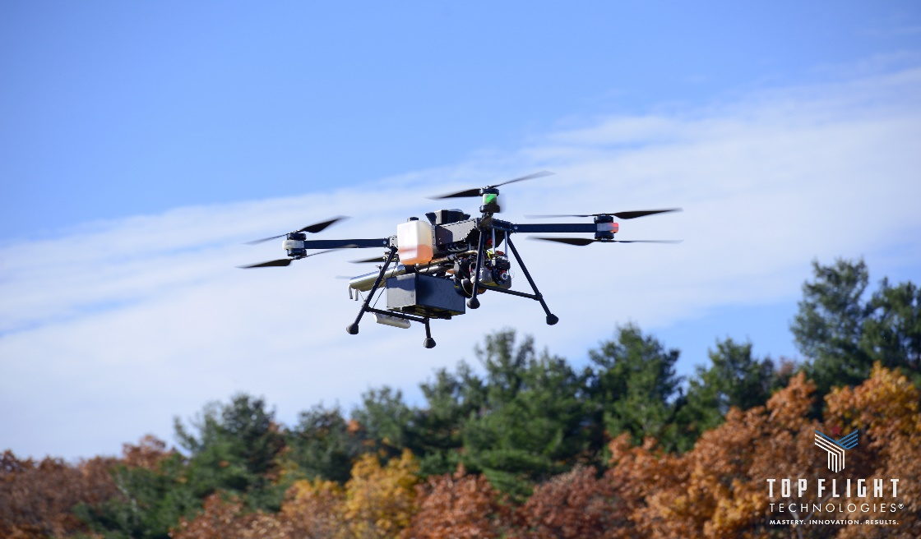

If you have completed the questions below and have other questions about how we can fast-adapt product solutions for your business need, please contact our customer support team at 774.855.6811 or email us at support@topflighttech.com.
1. Your contact information, company name, and business division.
Click or tap here to enter text.

2. What is the focus for your team? – End customer; Service Partner; Channel & Service Partner; R&D, etc.
Click or tap here to enter text.

3. Ideally, what do you want to achieve overall; not just with these types of discussions, but what is the outcome you want to drive and see achieved? – Specific UAV applications? Geographic Service or Channel Partnership? Participate in the Airborg® Engagement Program?
Click or tap here to enter text.

4. What are the key timelines and operating dependencies do you have to embark on this new solution or partnership?
Click or tap here to enter text.

5. What do you see as your challenges and risk from a process perspective, from an executive sponsorship perspective; and from a budgetary perspective to reaching your goals?
Click or tap here to enter text.

6. For UAV capabilities needed:
- List types of data to be collected: EO, SWIR, MWIR, LWIR, C02, gas, wind speed, temperature, etc.
Click or tap here to enter text.
- Expected operation flight time requirement, expected duty cycle of use?
Click or tap here to enter text.
- Do you require live telemetry?
Click or tap here to enter text.
- Do you require manual, semi-autonomous, or fully autonomous flights?
Click or tap here to enter text.
- Are you aware of the country-specific UAV regulations for > 55lb UAVs and those that operate them?
Click or tap here to enter text.
- Do you require assistance with post-collected data processing (data manipulation, storage analysis)?
Click or tap here to enter text.

9. Your expected project start time frame?
Click or tap here to enter text.

10. Is this project budget already approved?
Click or tap here to enter text.

11. Other miscellaneous information?
Click or tap here to enter text.

Along with this form, please attach any working documents or illustrations that may be relevant to ongoing application discussions and send to support@topflighttech.com. Thank you.

